

International School

**Capstone Project 1**

*CMU-SE 450*

**PROPOSAL DOCUMENT**

*Version: 2.1*

*Date: 27/12/2021*

**School Connect Application**

**Submitted by:**

Nguyen Thanh Phu

Nguyen Trung Hieu

Dang Nguyen Bao Hoai

**Approved by**

. Nguyen Minh Nhat

**Proposal Review Panel Representative:**

Name Signature Date

**Capstone Project 1- Mentor:**

Name Signature Date

# **Project Information**

|  |  |  |  |  |
| --- | --- | --- | --- | --- |
| **Project acronym** | SConA | | | |
| **Project Title** | School Connect Application | | | |
| **Start Date** | 22-Aug-2021 | **End Date** | | 18-Dec-2021 |
| **Lead Institution** | International School, Duy Tan University | | | |
| **Project Mentor & contact details** | Name: Nguyen Minh Nhat  Email: nhatnm2010@gmail.com  Tel: +84 905 125 143 | | | |
| **Scrum Master & contact details** | Name: Nguyen Thanh Phu  MSSV: 2321118121  Email: [thangphu104@gmai.com](mailto:thangphu104@gmai.com)  Tel: +84 772 492 301 | | | |
| **Name Team members** | **MSSV** | **Email** | **Tel** | |
| Nguyen Trung Hieu | 24211205927 | hnguyentrung20@gmail.com | +84 975 299 149 | |
| Dang Nguyen Bao Hoai | 24211215163 | dangbhoai@gmail.com | +84 773 305 395 | |

|  |  |  |  |
| --- | --- | --- | --- |
| **DOCUMENT INFORMATION** | | | |
| **Document Title** | Proposal | | |
| **Author(s)** | Team C1SE.44 | | |
| **Role** | C1SE.44-Proposal-SConA-v2.1 | | |
| **Date** | 27-Dec-2021 | **Filename** | C1SE.44-Proposal-SConAS 2.1 |
| **URL** | **https://github.com/PhuNguyenThang/Capstone1** | | |
| **Access** | Project and CMU Program | | |

**DOCUMENT APPROVALS**

The following signatures are required for the approval of this document.

|  |  |  |
| --- | --- | --- |
| Nguyen Minh Nhat  *Mentor* | Signature | Date |
| Nguyen Thanh Phu  *Scrum Master* | Signature | Date |
| Nguyen Trung Hieu  *Product owner* | Signature | Date |
| Dang Nguyen Bao Hoai  *Product owner* | Signature | Date |

REVISION HISTORY

|  |  |  |  |  |
| --- | --- | --- | --- | --- |
| **Version** | **Date** | **Comments** | **Author** | **Approval** |
| 1.0 | 19-Aug-2021 | Create Proposal | Phu, Nguyen Thanh |  |
| 2.0 | 11-Sep-2021 | Update current status of art and remove member Thang | Phu, Nguyen Thanh |  |
| 2.1 | 27-Dec-2021 | Update master plan and system context | Phu, Nguyen Thanh |  |

**TABLE OF CONTENTS**

Project Information 2

1. Introduction 5

2. Problem Definition 5

2.1. Business Problem 5

2.2. Business Need 6

3. Current Status of Art 6

4. Engineering Approach 7

2.1. System Context Overview 7

2.2. System Context Description 7

2.3. Technical Proposed 8

5. Tasks and Deliverables 9

5.1. Tasks 9

6. Project Management 12

6.1. Scrum 12

6.2. Master Plan 13

6.3. Human Resource 13

6.4. Task Assignment 14

6.5. Cost Estimate 14

7. Project Constraints 15

8. Conclusion 16

9. References 16

# **Introduction**

In the context of the pandemic COVID-19, communication between students and the school is very difficult. Most universities have thousands of students, so it has become very difficult for college students to keep in touch with the faculty & professors to get their problems solved. Earlier students all had to personally visit the school and had to meet the concerned person to get our queries solved, but the ongoing pandemic has brought a complete halt to this approach & switching to an alternative method has become a dire need nowadays. In addition, it has become very difficult for the college management to convey any important notice or message to all the students as all the college faculty members & students may not be using the same messaging app or they using a social network third party. Hence to solve this issue we have come up with a web-based School Connect Social Forum and Chat application where all the students & teachers can stay connected together on a single platform, thereby helping all the students to be in constant touch with the faculty and making it possible for them to get their problems solved in an instant. Hence, this application will help students to be in contact with their fellow mates & professors all the time without being physically present in a classroom.

**School Connect Application** is a web-based application with a school scope that allows students and teachers in that school to chat with each other inside the website without using a third-party application, students and teachers can post articles to the system for other teachers and students to view and comment on. Administrators can manage student and teacher account information as well as forum information. Controllers can moderate student and teacher posts and can control malicious comments or messages

# **Problem Definition**

## **Business Problem**

By using a regular way of communication between student and professor (mail, Facebook messenger).

* Annoying when having to receive emails or messages in social networks to solve petty problems.
* Professors and students may not use the same communication tools so they must use many apps to can chat together.
* [During pandemic] students may not know each other, and it is difficult to work as a team.
* Messages and notifications from professors and school clubs are always missed because they do not have a separate communication channel.
* Censorship of bad conversations and comments is very difficult.
* Security: using third-party apps made information of students or teachers can be exposed.
* There are too many to post and the comment is bad to be checking.

## **Business Need**

* Private and security from the outside.
* Notification about events or policies for students and teachers.
* Easy students and teachers can contact together.
* No effect on personal social media accounts.
* Manager in information student and teacher
* Manager all forums in the system
* Control posting, commenting, and chat.
* Students and teachers can report ca comments or message toxic

# **Current Status of Art**

Tab 1: Current Status

|  |  |  |  |
| --- | --- | --- | --- |
| **Function** | **College Connect Application** | **used.udn.vn (Da Nang Pedagogical University)** | **fr.dut.udn.vn**  **(Polytechnic University danang)** |
| Upload News | X | X | X |
| Upload Events | X | X | X |
| Update Profile | X | X | X |
| Calendar event | X |  |  |
| Chat | X |  |  |
| Have forum private | X |  |  |
| Notification new and message | X |  |  |
| Report message | X |  |  |
| Report comment | X |  |  |

# **Engineering Approach**

# **System Context Overview**

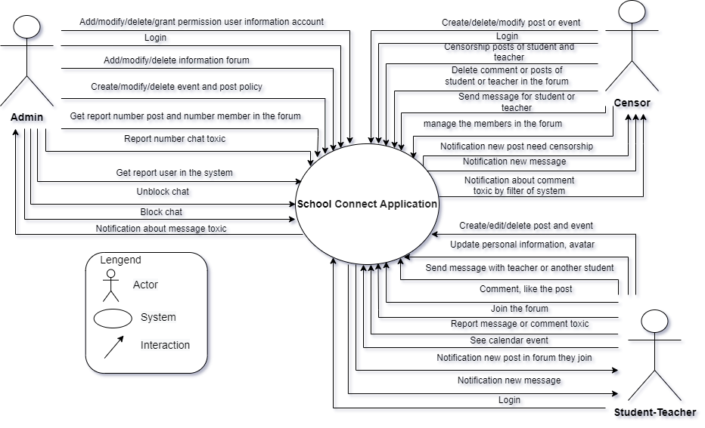

Fig 1: System context

## **System Context Description**

**The system comprises 3 major modules with their sub-modules as follows:**

* **Student-Teacher (user):**

Notification new post forum they join.

Create/edit/delete the post or event in the forum they join.

Login into a website.

Comment and like the post of they or another people.

Send a message to the teacher or another student in the system.

Update personal information, avatar.

See calendar event.

Join the forum.

Report message or comment toxic.

Notification new post forum they join.

Notification of new message

* **Censor:**
* Create/delete/modify the post or event
* Login into a website
* Censorship the new posts of student or teacher
* Sent message to student or teacher in the system.
* Delete comments, posts in the forum.
* Notification about comment toxic by the filter of system or teacher and student report
* Notification of the new post in the forum
* Notification of new message
* Censorship the request joins forum of the student or teacher
* Remove members from the forum
* **Admin:**
* Add/modify/delete/grant permission user information account.
* Add/modify/delete the forum.
* Get report user in the system
* Unblock chat
* Add/modify/delete event or post policy.
* Get report number chat toxic student and teacher report.
* Get report number posts and number of members in the forum.
* Login into a website.
* Block chat toxic.
* Notification about message toxic student and teacher report.

## **Technical Proposed**

* **Server:**
  + - Programming Language: JAVA.
    - Framework: Spring Boot 2.4.0.
    - Libraries: Maven.
    - Operating System: Windows, Linux, macOS.
    - Database: MySQL, Firebase.
    - Network Accessing: HTTP methods (POST, GET) via RESTful API.
* **User interface**
  + - Programming language: HTML, CSS, JavaScript. Tailwind CSS
    - Framework: VueJS.
    - Operating System: Windows, Linux, Mac OS.
    - Web Browser: Chrome, Firefox, Microsoft Edge, Coccoc, Opera.
    - Network Accessing: HTTP methods (POST, GET) via RESTful API
* **Other**
  + - Version Control System: Bitbucket.
    - Web Server Application: Apache Tomcat.
    - Development Tools: Visual Studio Code, IntelliJ IDEA.

# **Tasks and Deliverables**

## **Tasks**

Tab 2: Tasks

|  |  |  |
| --- | --- | --- |
| **Task** | **Sub-task** | **Activities** |
| **Task 1 – Project Initiation and Planning** | Sub-task 1 – Project Initiation and Management Plan | * Project Initiation * Project Initiation Planning * Project Kick-Off Presentation * Project proposal * Project Management Plan * Project Scope * Risk Analysis and Management * Project Work Plan and Schedule |
| Sub-task 2 – Regular Project Status Reporting | * At least 2 times a week |
| Sub-task 3 – System Design and Development Strategy | * System Design Methodology * System Design and Development Strategy |
| Sub-task 4 – System Implementation  Strategy | * System Implementation Strategy |
| Sub-task 5 – Master Testing Strategy | * Testing Strategy |
| Sub-task 6 – Requirements analysis | * Project user story * Project product backlog |
| **Task 2 – System, Interface, and Data Design** | Sub-task 7 – product backlog design document | * Functional Design Document |
| Sub-task 8 – Develop Data Plan, Functional Design Document | * Database Design Document |
| Sub-task 9 – Develop Interface Specifications and Design Document | * Develop Interface Specifications and Design Document |
| Sub-task 10 – System Architecture and Technical Design | * System Architecture and Technical Design |
| **Task 3 – System Development** | Sub-task 11 – System Implementation Plan | * System Development Methodology * Software Configuration Management |
| Sub-task 12 – Data Conversion, Synchronization | * Data Load * Testing Conversion |
| Sub-task 13 – System Maintenance, Support, and Transition Plan | * System Maintenance, Support, and Transition Plan |
| **Task 4 – System Testing** | Sub-task 14 – Detailed Test Plans | * Unit and Integration Testing * System Testing * User Acceptance Testing * Performance Testing * System Regression Testing |
| Sub-task 15 – Test Scenarios, Test Cases, Test Scripts | * Test Scenarios, Test Cases, Test Scripts |
| Sub-task 16 – Document System Test Results | * Document System Test Results |
| **Task 5 – Release**  **And Training** | Sub-task 17 - Release Readiness Evaluations and Reports | * College Connect Application System Readiness * Release Readiness Evaluation and Report |
| Sub-task 18 – Complete Detailed Requirements, Design & Specifications | * Complete Detailed Requirements, Design & Specifications |
| Sub-task 19 – Training and User manual | * Training and guiding for actor |

* 1. **Deliverables**

Tab 3: Deliverables

|  |  |  |
| --- | --- | --- |
| No. | Task name | Description |
| **1.** | **Startup** |  |
| 1.1 | Project kick-off meeting | Encountering the developer team and stakeholders to clear out the goal, defining the base elements for the project, and other project planning activities. |
| 1.2 | Discuss project | Brighten up the current ideal to both the developer  team and stakeholders. |
| 1.3 | Create Document | Release the artifacts or schematics related to the project to the product owner, including Proposal, Project Plan, User Story, Product backlog, … |
| **2.** | **Development** |  |
| 2.1 | Sprint Planning | A Sprint begins with a sprint planning session that sets goals and plans details for the work to be done. |
| 2.2 | Sprint 1 | Release the first look of the product with functions that have been committed in the plan. |
| 2.3 | Sprint 2 | Release the functionality of the product with those committed to the plan. |
| 2.4 | Sprint 3 | Release the functionality of the product with those committed to the plan. |
| 2.5 | Sprint 4 | Release the functionality of the product with those committed to the plan. |
| **3.** | **Project ‘s meeting** | The private meeting between members to plan what will be presented to the customer in the final release. |
| **4.** | **Final Release** | Release the final version to the product owner with complete function. |

# **Project Management**

## **Scrum**

***Introduction scrum process***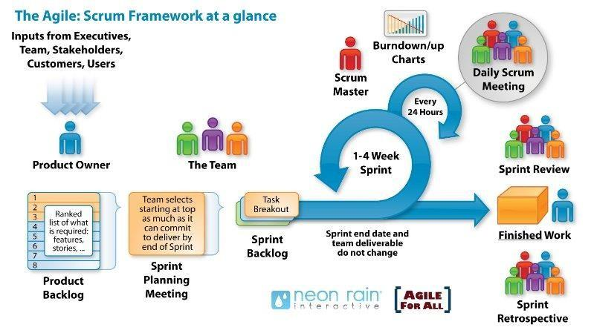

Fig 2: Scrum model

* Scrum is an iterative and incremental agile software development framework for managing software projects and product or application development.
* Scrum focuses on project management institutions where it is difficult to plan.
* Mechanisms of empirical process control, where feedback loops that constitute the core management technique are used as opposed to traditional command-and-control management.
* Its approach to planning and managing projects is by bringing decision-making authority to the level of operation properties and certainties.
* Benefit of the methodology:
  + Project can respond easily to change.
  + Problems are identified early.
  + Customer gets most beneficial work first.
  + Work done will better meet the customer’s needs.
  + Improved productivity.
  + Ability to maintain a predictable delivery schedule.
* **Why did we choose the Scrum process to develop the system?**

In the future, in addition to the above features, our development team is more likely will integrate the student calendar in the myDTU system to import the class information and many other advanced functions, if possible. Moreover, the scrum process is a flexible development model so in this case, it is suitable for this project.

This is the first time the team works together, the experience is not much, it will certainly be difficult in the development process. For the traditional model, we are not allowed to make mistakes but for our scrum, it allows us to make mistakes, through each sprint we will discuss, inspect and adapt to work better.

## **Master Plan**

Tab 4: Master Plan

|  |  |  |  |  |  |
| --- | --- | --- | --- | --- | --- |
| **No.** | **Task Name** | **Duration**  **(days)** | **Hours** | **Start** | **Finish** |
| **1.** | **Initial** | **19** | **142.5** | **18/8/2021** | **05/9/2021** |
| 1.1 | Project’s Kick-off Meeting | 5 | 37.5 | 18/8/2021 | 22/8/2021 |
| 1.2 | Research technical and create a document | 14 | 105 | 23/8/2021 | 05/9/2021 |
| **2** | **Development** | **98** | **735** | **06/9/2021** | **12/12/2021** |
| 2.1 | Sprint 1 | 28 | 210 | 06/9/2021 | 03/10/2021 |
| 2.2 | Sprint 2 | 28 | 210 | 4/10/2021 | 31/10/2021 |
| 2.3 | Sprint 3 | 21 | 157.5 | 01/11/2021 | 21/11/2021 |
| 2.4 | Sprint 4 | 21 | 157,5 | 22/11/2021 | 12/12/2021 |
| **f** | **Close project** | 2 | 15 | 13/12/2021 | 15/12/2021 |
| **Total** | | **119** | **892.5** |  |  |

## **Human Resource**

Tab 5: Human Resource

|  |  |  |  |
| --- | --- | --- | --- |
| **Full Name** | **Phone** | **Email** | **Position** |
| Nguyen Minh Nhat | +84 905 125 143 | nhatnm2010@gmail.com | Mentor |
| Nguyen Thanh Phu | +84 772 492 301 | thangphu104@gmail.com | Scrum Master, Dev Team |
| Nguyen Trung Hieu | +84 975 299 149 | hnguyentrung20@gmail.com | Product Owner, Dev Team |
| Dang Nguyen Bao Hoai | +84 773 305 395 | dangbhoai@gmail.com | Product Owner,  Dev Team |

## **Task Assignment**

Tab 6: Task Assignment

|  |  |
| --- | --- |
| **Assign** | **Main Task** |
| Nguyen Thanh Phu | Create Document: Proposal, Database Design, Architecture Design, Project Plan  Research: Spring Boot, JAVA, Firebase, MySQL, Socket.io, RESTful API |
| Nguyen Trung Hieu | Create Document: Product Backlog, Sprint Backlog, Design UI, UX, Design Front End, Test Plan, Test case, etc.  Research: VueJS, Socket.io, Firebase, Restful API, Ajax, Json |
| Dang Nguyen Bao Hoai | Create Document: User story, Design UI, UX, Design Front End, Test case, etc.  Research: VueJS, Firebase, Restful API, Ajax, JSON |

## **Estimate**

Timeline

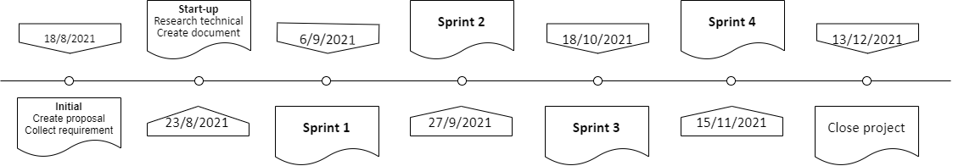

## **Cost Estimate**

Tab 7: Total Cost

|  |  |  |  |  |
| --- | --- | --- | --- | --- |
| **No.** | **Criteria** | **Price (USD/hour)** | **Amount** | **Total (USD)** |
| 1 | Working hour | 2 | 944 | 1.888 |
| 2 | Management cost (**estimating, allocating, and controlling project costs**) | 20% |  | 378 |
|  | | | **Total** | 2.266 |

Tab 8: Cost Description

|  |  |  |
| --- | --- | --- |
| **Description** | **Amount** | **Unit** |
| Number of members | 3 | Person |
| Number of working-day per week/ person | 7 | Day |
| Number of working-hour per week/ person | 18 | Hour |
| The cost person member per week | 36 | USD |
| The duration of the project | 15 | Week |
| The number of working days | 119 | Day |

**Explain:**

* Amount of working hours = 3 members * 18 hours * 15 weeks.
* Management cost = total * 20%

# **Project Constraints**

# Tab 9: Project Constraints

|  |  |  |
| --- | --- | --- |
| **Constraint** | **Constraints Description** | **Guidelines for Acceptance** |
| **Ethical** | This is a system for people of school so outsiders can’t go into system destructive forum  Information of students or teachers can’t expose. | Ethical considerations can be broad. Areas that are typically addressed include intellectual property, reverse- engineering, privacy, security, and the conflict between cost and safety |
| **Public health, safety, and welfare** | In the context of the epidemic student and teachers don’t need to meet face to face to limit the spread of disease | Includes safety standards as well as the impact of the design on users (for example, electrical or physical hazards) |
| **Cultural** | This application can change communication students can contact with school or teacher event they don’t at school or use many third apps to hold contact | Which cultural characteristics could influence the approach?  How does the design from different cultures differ? |

# 

# **Conclusion**

The disease still is a problem global now, Software will be solving the problem contact of students and schools. Software products run on multiple platforms but in a short time we will run the web, this product helps students, alumni, and stakeholders access school news accurately and quickly, stakeholders can text messages to exchange knowledge and job recruitment.

It is expected that the system will be deployed and completed within near four months. Each team member will work 2 hours per day for 1 hour 2 USD to maintain until the project is completed.

# **References**

[1]. Software Development Standards for the Guidance and Control Software Project [*https://sw-eng.larc.nasa.gov/*](https://sw-eng.larc.nasa.gov/)

[2]. General Software Coding Standards and Guidelines [*https://www.nws.noaa.gov/oh/hrl/developers_docs/General_Software_Standards.pdf*](https://www.nws.noaa.gov/oh/hrl/developers_docs/General_Software_Standards.pdf)

[3]. Scrum and best practices [*https://docs.microsoft.com/en-us/azure/devops/boards/sprints/best-practices-scrum?view=azure-devops*](https://docs.microsoft.com/en-us/azure/devops/boards/sprints/best-practices-scrum?view=azure-devops)

[4]. The Scrum Guide [*https://www.scrum.org/resources/scrum-guide*](https://www.scrum.org/resources/scrum-guide)

[5.] The ISO/IEC & *IEEE*/*EIA* Standard 12207, IEEE standards: IEEE-829 [3], IEEE-1008, IEEE-1012